
REPUBLIC OF CAMEROON
PEACE-WORK-FATHERLAND
UNIVERSITY OF BUEA
BUEA, SOUTH-WEST REGION
P.O BOX 63.

RÉPUBLIQUE DU CAMEROUN
PAIX-TRAVAIL-PATRIE
UNIVERSITÉ DE BUEA
BUEA, RÉGION DU SUD-OUEST
B.P. 63.

FACULTY OF ENGINEERING TECHNOLOGY

Group 23
Report on Requirement Gathering for A Mobile App to collect Quality of Service Data from Users

Course Title: Internet Programming and Mobile App Development

Course code: CEF440

Course Instructor: Dr Nkemeni Valery

Date: 27th April, 2026

Group 23 Members
NAME | MATRICULE
- THELMA MARLEY NDAYINU | FE23A171
- EKWEMBWE NKWELLE JUNIOR | FE23A044
- MBUH ASSURANCE MULUH PILA | FE23A091
- NYUH DELBERT KIMBI | FE23A129
- YASIRI TEMWA GASTON | FE23A175

Table of Content
1.0 Cover Page ………………………………………………………………………….. 1
1.1 Team Members ……………………………………………………………………..2
1.2 Table of Content ……………………………………………………………………3
2.0 Introduction to Requirement Gathering ……………………………………………..4
2.1 Stakeholder Identification …………………………………………………………5
2.1.1 Smartphone Users (Mobile Network Subscribers)
2.1.2 Network Service Providers (MTN, Orange, Camtel)
2.2 Requirement Gathering Techniques …………………………………………………8
2.2.1 Survey (Google Forms)
2.2.2 Interviews (MTN Technical Staff)
2.2.3 Comparative Insight (Survey vs Interview)
2.3 Data Gathering ………………….……………………………………………..…11
2.4 Data Cleaning ………………….………………………………………………..13
2.4.1 Issues Identified in Raw Data
2.4.2 Cleaning Steps Applied
2.4.3 Cleaned Workbook Structure
2.4.4 Before and After Comparison
2.4.5 Summary
2.5 Key Insights From Data ………….……………………………………………..…19
2.6 User Reluctance Assessment ….………………………………………………..24
2.7 Summary of Findings ……………..………………………………………………..25

WEEK PROGRESS REPORT
2.0 Introduction to Requirement Gathering
Mobile networks continue to evolve, and users’ expectations regarding service quality and network performance have significantly increased. As stated in our problem description, “mobile subscribers often experience fluctuations in network quality, service delays, and unexpected outages.” Despite the presence of advanced monitoring systems, “current methods used by mobile network operators to monitor performance do not sufficiently incorporate real user experiences, leading to an incomplete understanding of service quality.” Furthermore, there is “a lack of tools that allow real-time, automated, and user-friendly collection of both subjective and objective QoE data,” creating a gap in the ability of operators to proactively address network issues.
In response to this gap, this project focuses on the design and implementation of a mobile application capable of collecting real-time user experience data (Quality of Experience, QoE) alongside relevant network performance indicators. To ensure that the proposed solution is grounded in real-world needs, a structured requirement gathering process was conducted.
This process involved two primary approaches. First, a large-scale survey was administered using Google Forms to collect quantitative and qualitative data from smartphone users who are active mobile network subscribers. A total of 123 responses were collected across multiple regions in Cameroon, capturing user behaviour, perceived network quality, common issues, and willingness to adopt a monitoring solution. Second, an interview was conducted with a senior staff member in the technology department of a major network provider (MTN) to gain insight into existing systems, operational constraints, and industry practices.
The objective of this requirement gathering phase is to clearly identify stakeholders, understand their challenges and expectations, and collect reliable data that will inform the design of the proposed system. The findings from this section will serve as the foundation for requirement analysis, system modelling, and implementation in subsequent phases of the project.

2.1 Stakeholder Identification
Identifying the key stakeholders is essential to understanding who is affected by the problem and whose needs must be addressed by the proposed solution. Based on the nature of this project and the data collected, two primary stakeholder groups were identified: smartphone users (mobile network subscribers) and network service providers.
2.1.1 Smartphone Users (Mobile Network Subscribers)
Smartphone users represent the primary stakeholders of this system, as they are the direct consumers of mobile network services and the main source of Quality of Experience (QoE) data.
From the survey conducted, it is evident that mobile internet usage is highly prevalent among respondents. Approximately 89.5% of users reported using mobile internet very frequently, indicating a strong dependence on mobile connectivity for daily activities. These activities include social media (73.8%), messaging (66.4%), online classes/work (59%), and browsing (47.5%), showing that mobile data plays a critical role in communication, education, and productivity.
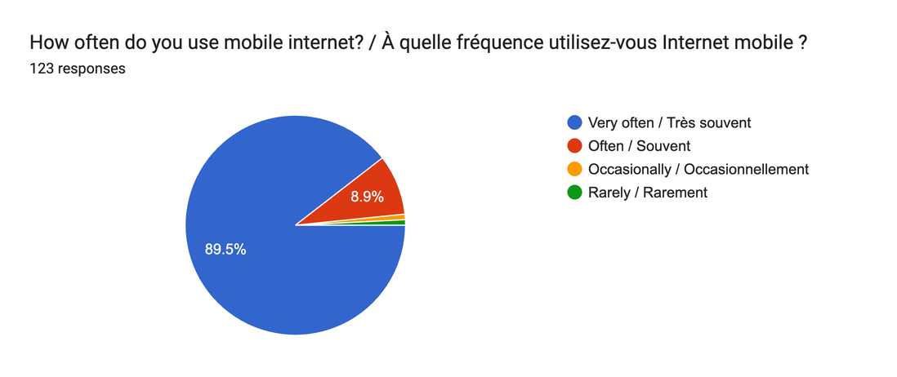
Despite this high level of usage, user experience remains largely unsatisfactory. Only a very small percentage of users rated their network experience as good or excellent, while the majority classified it as average (51.6%), poor (27.9%), or very poor (19.7%). In addition, 82.9% of respondents identified slow internet as their most frequent issue, followed by poor call quality (38.5%) and network outages (35.2%).
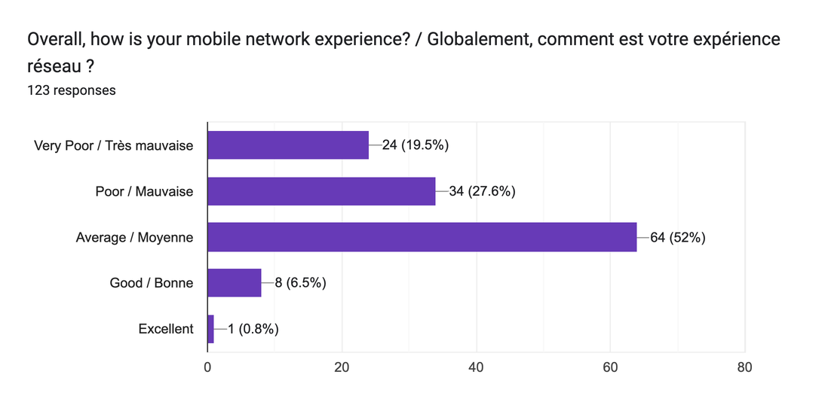

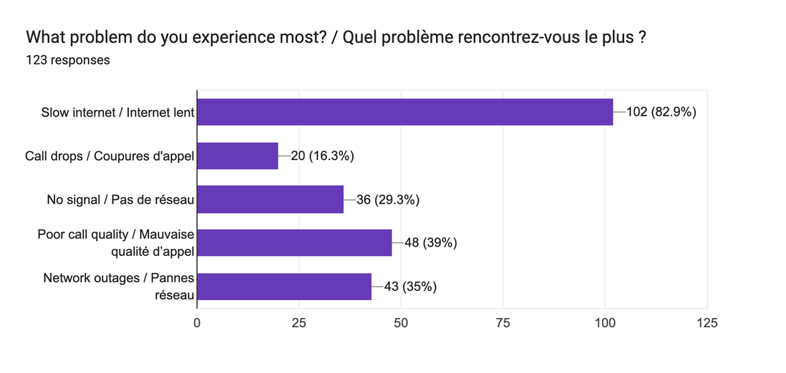
These findings highlight a significant mismatch between user dependence on mobile networks and the quality of service experienced.
Key Challenges Faced by Users:
- Frequent slow internet speeds
- Unstable connections and service interruptions
- Poor overall reliability of network services
- Limited visibility into the cause of network issues
User Needs:
- Improved and consistent network performance
- A platform to report and monitor their network experience
- Greater transparency regarding network quality
- A lightweight and non-intrusive solution that does not heavily impact battery or data usage
2.1.2 Network Service Providers (MTN, Orange, Camtel)
Network service providers are secondary stakeholders, as they are responsible for delivering network services and would potentially utilize the insights generated by the proposed system to improve service quality.
From the survey data, MTN is the dominant provider among respondents, accounting for 87% of users, followed by Orange (38.2%) and Camtel (16.3%). This indicates that any proposed solution should be scalable and relevant to major providers, particularly MTN.
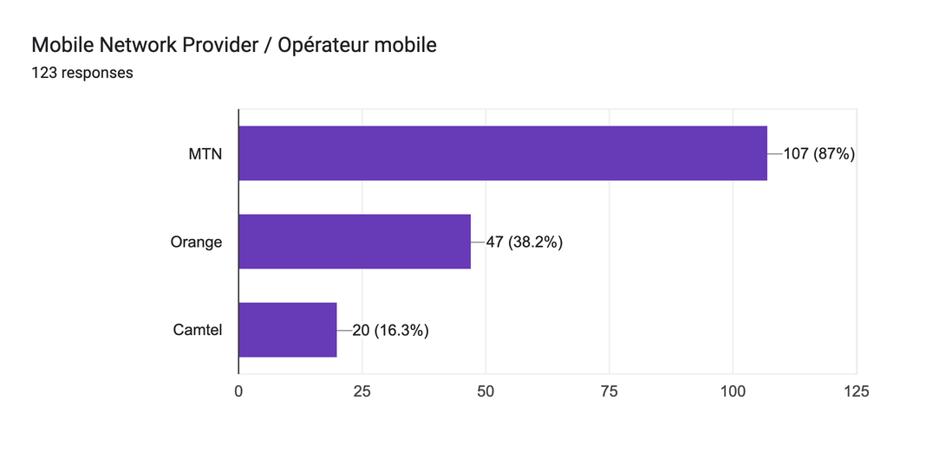
An interview conducted with a senior manager in the technology department of MTN provided additional insight into the provider’s perspective. It was confirmed that MTN already performs real-time network monitoring and has mature systems for managing network performance and service quality. However, access to detailed operational data is restricted due to confidentiality and security requirements.
While these systems provide strong technical monitoring (Quality of Service, QoS), they do not fully capture the real-time, contextual experience of users from a human perspective. Additionally, the confidentiality of internal data limits external visibility into user complaints and detailed performance metrics.
Key Challenges Faced by Providers:
- Difficulty in accessing real-time, user-specific experience data at scale
- Limited ability to directly correlate user perception with network performance metrics
- Data confidentiality and security constraints
Provider Needs:
- More granular and user-centered QoE data
- Context-aware insights (location, time, usage type)
- Tools that complement existing monitoring systems without compromising security
This stakeholder analysis demonstrates that while users experience significant network challenges, providers already possess strong technical monitoring capabilities. The gap between these two perspectives reinforces the need for a system that bridges technical network data and real user experience.
2.2 Requirement Gathering Techniques
To ensure that the proposed system is based on real user needs and aligned with industry practices, multiple requirement gathering techniques were employed. These techniques focused on collecting both quantitative and qualitative data from relevant stakeholders.
2.2.1 Survey (Google Form: https://forms.gle/dWyGXKHuuYGdahLy7)
A structured survey was designed and distributed using Google Forms to collect data from smartphone users who are active mobile network subscribers. The survey targeted users across different regions and usage patterns to obtain a broad and representative dataset.
A total of 123 valid responses were collected. The questionnaire included a mix of multiple-choice questions, rating scales, and optional open-ended inputs. The survey focused on the following key areas:
- User demographics and device types
- Mobile internet usage behaviour
- Perceived network performance (QoE)
- Common network issues encountered
- Impact of network quality on daily activities
- Willingness to adopt a mobile application for monitoring network experience
- Privacy and data-sharing concerns
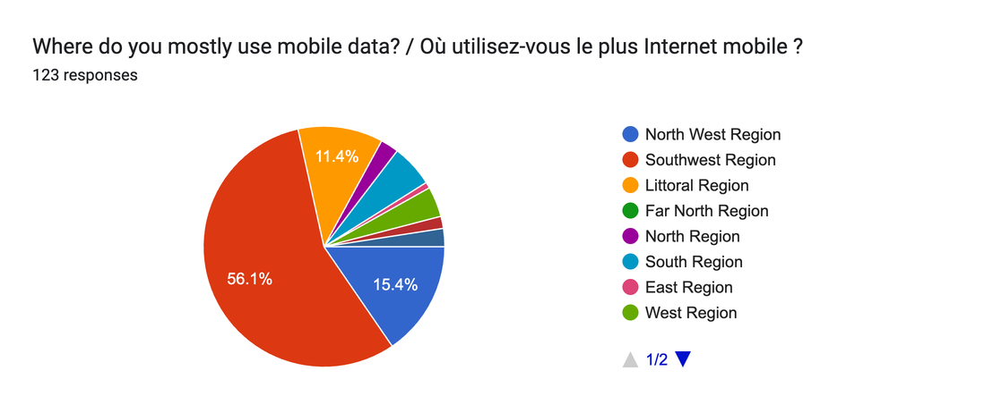




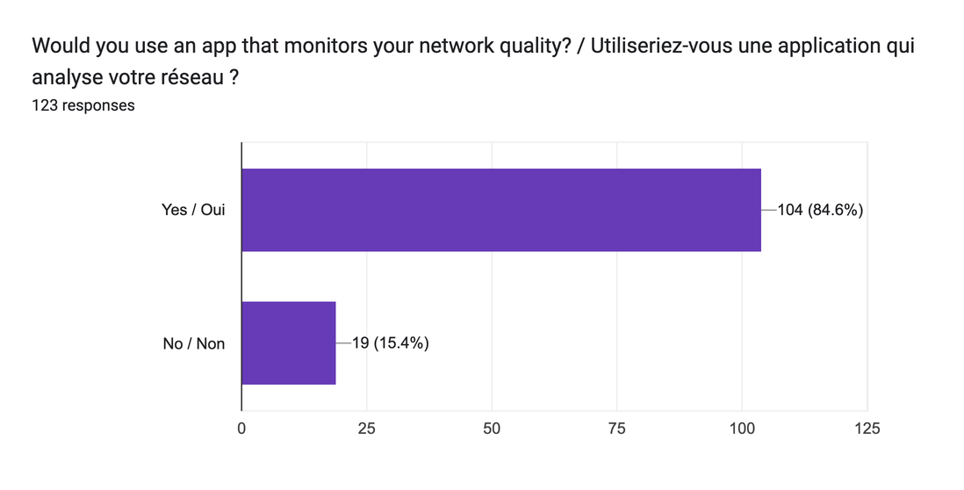

The survey provided large-scale, user-driven insights into how mobile networks are experienced in real-life scenarios. It also helped identify patterns in user dissatisfaction, usage intensity, and acceptance of potential solutions.
2.2.2 Interviews (Network Provider – MTN)
To complement the user survey, an interview was conducted with a senior manager in the technology department of MTN. The purpose of this interview was to gain insight into existing network monitoring systems, operational practices, and constraints from the provider’s perspective.
The discussion revealed that:
- MTN performs real-time monitoring of network performance using advanced systems
- The organization has mature service management processes and adheres to industry standards
- Access to detailed operational data is restricted due to confidentiality and security requirements
- Root cause analysis of network issues is becoming more efficient with modern technologies
These insights confirm that network providers already have strong Quality of Service (QoS) monitoring capabilities. However, they also highlight limitations in terms of external access to data and the absence of direct, real-time user experience integration.
2.2.3 Comparative Insight (Survey vs Interview)
By combining the findings from both the survey and the interview, a critical observation emerges.
On one hand, users report frequent issues such as slow internet, unstable connections, and overall poor experience. On the other hand, the network provider confirms the presence of advanced monitoring systems and continuous performance tracking.
This contrast highlights a key gap:
- Network providers focus primarily on technical performance metrics (QoS)
- Users evaluate the network based on their personal experience (QoE)
The absence of a system that directly connects these two perspectives leads to an incomplete understanding of service quality.
This reinforces the relevance of the proposed solution, which aims to bridge this gap by collecting real-time, user-centered QoE data and linking it with network conditions.
2.3 Data Gathering
The data gathering process was designed to collect relevant, diverse, and reliable information from smartphone users who actively use mobile network services. The primary tool used for data collection was Google Forms, which enabled efficient distribution and structured response collection.
The survey was shared through personal networks and communication platforms such as WhatsApp, targeting individuals across different regions in Cameroon. This approach allowed for quick reach and a relatively diverse respondent base while remaining within the scope of available resources.
A total of 123 responses were collected, covering multiple regions including the Southwest, Northwest, Littoral, West, and others. The Southwest Region accounted for the highest proportion of responses (56.1%), followed by the Northwest Region (15.4%) and Littoral Region (11.4%), ensuring that the dataset reflects real user experiences across different geographic contexts.


The questionnaire was structured to capture different categories of data relevant to the project:
- Demographic and Device Data:
Information on user age range and device type (e.g., Android or iPhone), which can influence network experience.
- Usage Behavior:
Frequency of mobile internet usage and primary activities such as social media, messaging, video streaming, and online work.
- Perceived Network Experience (QoE):
User ratings of overall experience, internet speed, reliability, and frequency of issues such as video buffering.
- Network Issues:
Common problems encountered, including slow internet, call drops, no signal, poor call quality, and network outages.
- Contextual Factors:
Time and location where network performance is worst, providing insight into possible congestion patterns.
- Adoption and Feedback:
Willingness to use a mobile application for monitoring network quality and preferences for feedback frequency.
- Privacy and Concerns:
User concerns regarding data collection, including privacy, security, battery usage, and data consumption.
This structured approach ensured that both subjective user perceptions (QoE) and contextual usage data were captured effectively. The collected data serves as a strong foundation for identifying patterns, validating the problem statement, and guiding the design of the proposed system.
2.4 Data Cleaning
Upon exporting the survey responses from Google Forms, the raw dataset presented several structural and quality issues that required systematic cleaning before analysis could begin. A total of 120 responses were collected. The cleaning process was carried out using Microsoft Excel and was structured across four dedicated worksheets to ensure transparency, traceability, and reproducibility. No responses were deleted during any stage of the cleaning process.
2.4.1 Issues Identified in the Raw Data
Five distinct problems were identified upon inspection of the exported CSV file:
- Privacy exposure: Google Forms captured respondents’ email addresses in the Username column. These constituted personally identifiable information (PII) and could not be retained in the working dataset.
- Bilingual response values: Because the survey form was designed bilingually in English and French, every question and every answer option was presented in both languages. As a result, each exported cell contained both the English and French values separated by the delimiter “ / ” (e.g., Good / Bien or Very often / Très souvent). This duplication rendered the data unanalysable without first isolating a single language.
- Verbose and bilingual column headers: The column headers in the exported dataset were the full question text as written in the form, including both English and French (e.g., Mobile Network Provider / Opérateur mobile). Headers of this length are impractical for analysis and referencing. They were shortened to concise, meaningful English phrases such as "Network Provider", "Region", and "Age Range" while preserving the intent of each question.
- Duplicate question column: The question "How often do you use mobile internet?" appeared twice in the form, resulting in two separate columns for the same variable in the exported dataset. Retaining both would have created ambiguity and redundancy in the analysis.
- Multi-select responses: Six questions allowed respondents to select more than one answer option simultaneously. These were: Network Provider, Phone Type, Main Data Usage, Main Problem, Problem Location, and App Concerns. In the exported data, multiple selections within a single response were concatenated into one cell using a semicolon delimiter (e.g., MTN;Orange). Standard single-value frequency analysis cannot be applied directly to such cells without distorting results.

2.4.2 Cleaning Steps Applied
Step 1: Respondent Anonymisation
All email addresses in the Username column were replaced with sequential anonymous identifiers in the format User_1, User_2, … User_120. This was applied uniformly across all 120 records in the Raw_Data worksheet. The anonymized labels carry no identifying information while preserving the ability to trace each record across sheets.
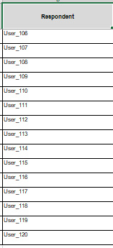
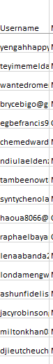
Before After

Step 2: Column Header Standardization
All column headers were renamed from their original full bilingual question text to short, descriptive English phrases. For example, "Mobile Network Provider / Opérateur mobile" became "Network Provider" and "Where do you mostly use mobile data? / Où utilisez-vous le plus Internet mobile?" became "Region". This was applied consistently across all 21 columns to make the dataset readable and easy to reference throughout the analysis.
Before:
After:
Step 3: Removal of bilingual Text
The English portion of each bilingual response was extracted using the Excel TEXTBEFORE function, which returns all text occurring before a specified delimiter. The formula applied to each cell in the Clean_Data worksheet was:
=IFERROR(TEXTBEFORE(Raw_Data!XX," / "), Raw_Data!XX)
The IFERROR wrapper ensures that cells not containing the " / " delimiter, such as numeric ratings or already-clean values, are returned unchanged. This was done to make the data less bulky and easy to understand.
Before:
After:

Step 4: Duplicate Question Resolution
The duplicate "Concerns" column was resolved by retaining only the first response from the affected column.
Before:
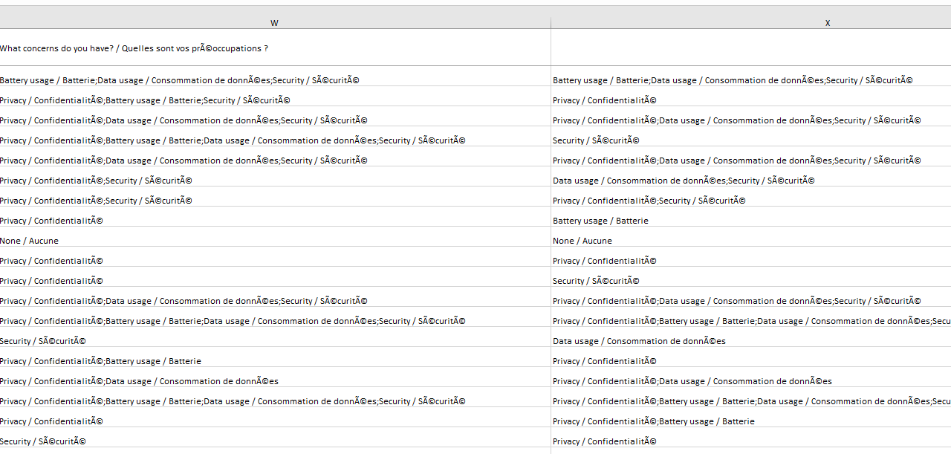
After:
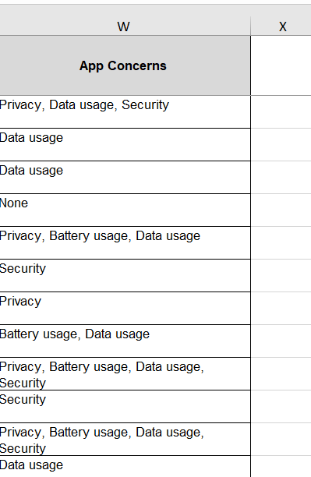

Step 5 : Multi-Select Handling via Multi-Response Analysis
For the six multi-select questions, the original comma-separated values were retained intact in the Processed_Data worksheet. No splitting or deletion of any selected option was performed. Analysis of these columns was conducted using a multi-response percentage approach in the Summary worksheet, where the percentage for each option is calculated relative to the total number of individual selections made across all respondents, rather than relative to the number of respondents. This approach ensures that the resulting percentages sum to exactly 100% and accurately reflect the distribution of choices without artificial inflation. The formula applied was:
Percentage = (Count of option) ÷ (Total selections) * 100
Option counts were computed in the Summary sheet using the COUNTIF function with wildcard matching to correctly identify each option across cells containing multiple comma-separated values:
=COUNTIF(range, "*Option*")
The percentage for each option was then calculated as:
=IFERROR(count / Total selections * 100)
2.3.3 Cleaned Workbook Structure
The cleaned dataset is organized across four worksheets within a single Excel workbook. This structure separates raw data from transformed data and from analysis outputs, enabling independent verification of each stage.

Sheet | Description
Raw_Data | Original 120 responses as exported from Google Forms. Emails replaced with User_1 to User_120. No other modifications.
Clean_Data | Bilingual values stripped to English using TEXTBEFORE formulas referencing Raw_Data. Duplicate column removed.
Processed_Data | Final analysis-ready dataset. English only, 120 rows, shortened column headers, all 21 questions present. Multi-select cells retain comma-separated English values.
Summary | Dedicated frequency analysis tables for the six multi-select questions, applying the multi-response percentage formula. Referenced directly from Processed_Data.
2.4.4 Before and After Comparison
Table 2 and Table 2.1 below illustrates the data before and after the cleaning.
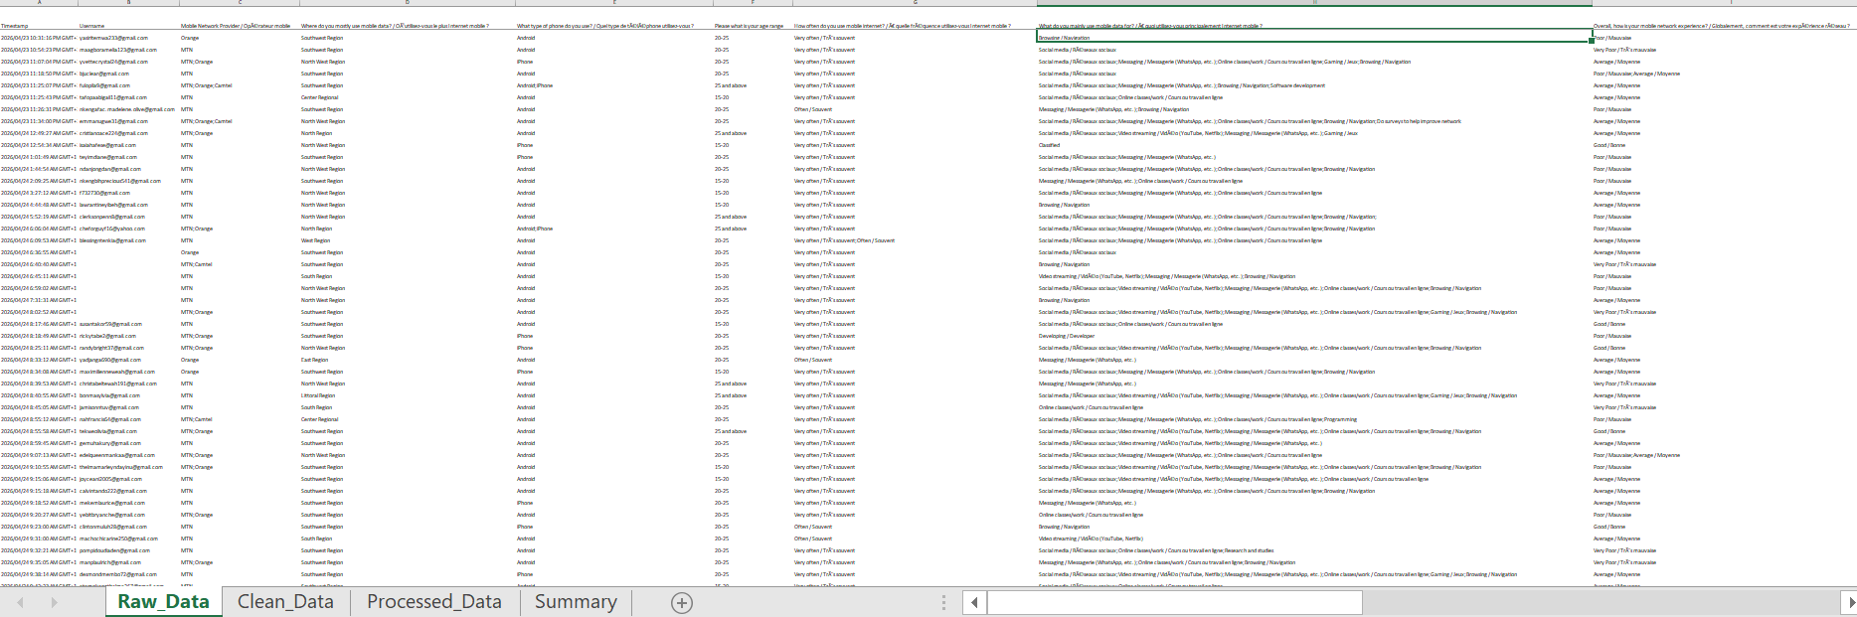
Table 2: Table snippet before and after data cleaning.
Processed Data: After Cleaning
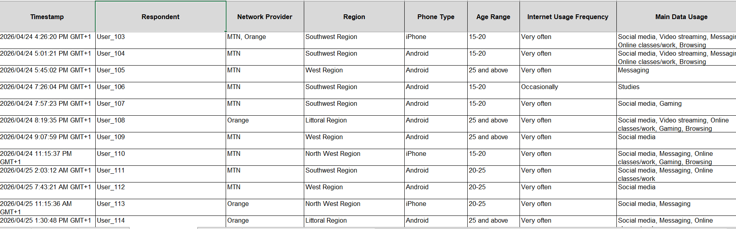
Table 2.1: Table snippet before and after data cleaning.
2.3.5 Summary
Following the completion of all cleaning steps, the dataset comprised 120 valid, anonymized, English records, with one duplicate column removed and all column headers standardized to concise English phrases. All multi-select responses were preserved in full and are analyzed separately using the multi-response percentage method. The cleaning process introduced no data loss: every submitted response is present and accounted for in the final Processed_Data worksheet.
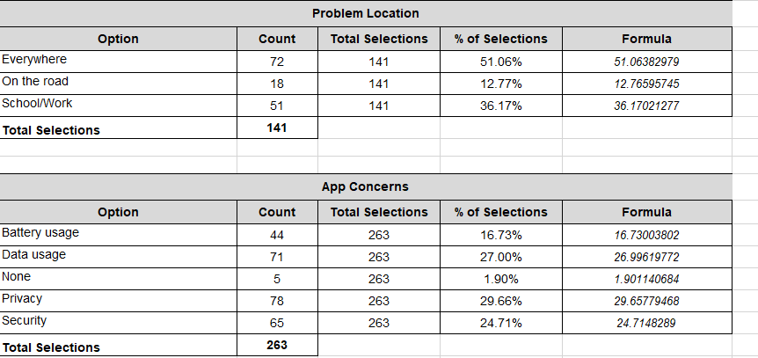
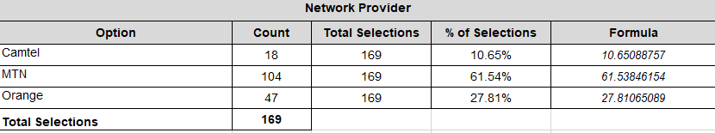

The data collected from 120 respondents reveals a consistent pattern of poor mobile network quality, with only 5% rating their overall experience as good, 66% experiencing problems often or very often, and slow internet identified as the dominant issue at 42% of selections. MTN emerged as the leading provider at 62%, while the high reliance on multiple networks signals distrust in service consistency. Despite these challenges, 84% of respondents expressed willingness to use a network monitoring app and 76% consented to automatic data collection, strongly validating the need for this project. These patterns, particularly around service quality, user pain points, and privacy concerns, will directly drive our design decisions, requirement prioritization, and the ethical framework guiding the application's data collection mechanisms.
2.5 Key Insights From Data
The analysis of the collected data revealed several important patterns that directly support the problem statement and guide the direction of the proposed solution. Only insights relevant to understanding user experience (QoE) and system requirements are presented.
Insight 1: High Dependence on Mobile Internet
The majority of respondents rely heavily on mobile internet for daily activities. Approximately 89.4% of users reported using mobile internet very often, with key activities including social media (73.8%), messaging (66.4%), online classes/work (59%), and browsing (47.5%).
This indicates that mobile connectivity is not optional but essential for communication, education, and productivity.


Insight 2: Poor User Experience Despite High Usage
Despite heavy reliance on mobile networks, overall user satisfaction remains low. Only a small fraction of users rated their experience as good (6.6%) or excellent (0.8%), while the majority rated it as average (51.6%), poor (27.9%), or very poor (19.7%).
This confirms a clear mismatch between user expectations and actual service quality.


Insight 3: Slow Internet is the Dominant Issue
A significant 82.9% of respondents identified slow internet as the most common problem. Other notable issues include poor call quality (39%), network outages (35%), and lack of signal (29.3%).
This highlights that performance degradation, particularly speed, is the primary concern affecting user experience.


Insight 4: Network Problems are Frequent and Widespread
Network issues are not occasional. About 69% of users experience problems often or very often, while 60.7% reported experiencing issues everywhere rather than in specific locations.
This suggests that network performance challenges are systemic rather than isolated.
Insight 5: Time-Based Performance Degradation
Network performance is reported to be worst during high-usage periods, particularly in the afternoon (48.4%) and evening (33.6%).
This indicates possible congestion patterns, where increased user demand impacts network quality.
Insight 6: Streaming Experience Highlights QoE Issues
Video streaming performance serves as a strong indicator of network quality. More than half of the respondents (approximately 54%) reported that videos buffer often or always.
This reflects limitations in bandwidth and stability, especially during data-intensive activities.
Insight 7: Strong Willingness to Adopt a Solution
There is clear interest in a solution to monitor network quality. About 84.6% of respondents indicated they would use an application that analyzes their network performance.
Additionally, approximately 76% are willing to allow automatic data collection, suggesting openness to participation if value is clear.

Insight 8: Privacy and Trust are Major Concerns
Despite willingness to adopt the solution, users expressed significant concerns regarding data collection. The main concerns include privacy (65.9%), data usage (60.2%), security (55.3%), and battery consumption (38.2%).
This indicates that trust, transparency, and efficiency must be central considerations in the system design.
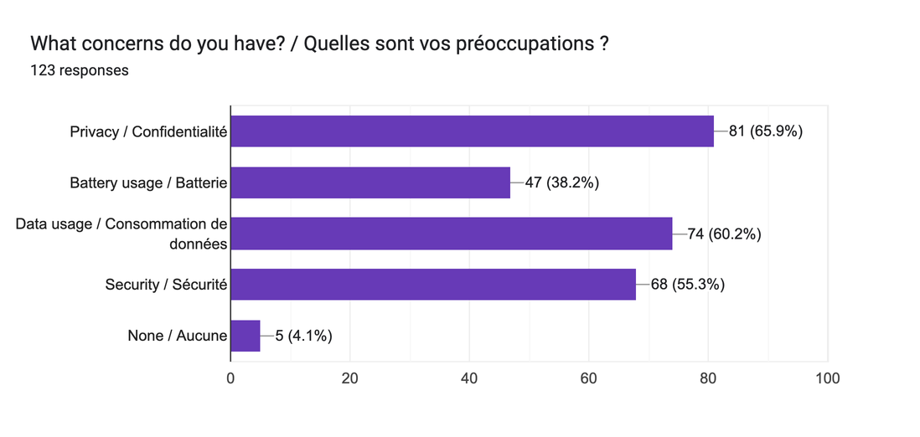

Insight 9: Preference for Context-Aware Feedback
A majority of users (46.8%) prefer that feedback requests occur only when there is a problem, rather than at fixed intervals.
This suggests that users favor intelligent, event-based interaction over frequent or intrusive prompts.
These insights collectively validate the problem statement and highlight the need for a system that captures real-time, user-centered network experience data. They also provide a clear direction for designing a solution that is responsive, lightweight, and sensitive to user concerns.
2.6 User Reluctance Assessment
Understanding user reluctance is essential for designing a system that is both usable and widely accepted. The data collected reveals concerns from both users and network providers.
From Users
Survey responses indicate that while users are generally willing to adopt a network monitoring application, they have clear concerns regarding data collection:
- Privacy concerns were reported by 65.9% of respondents
- Data usage concerns by 60.2%
- Security concerns by 55.3%
- Battery consumption concerns by 38.2%
These concerns suggest that users are cautious about how their data is collected, stored, and used. Any solution that does not address these concerns risks low adoption and trust issues.
From Network Providers
Insights from the interview with the MTN representative highlight similar concerns from the provider side. Data related to network performance and user behavior is treated as confidential and is not openly shared. This is due to security policies, regulatory requirements, and operational sensitivity.

Key Observation
Both users and providers demonstrate reluctance regarding data sharing, though for different reasons:
- Users are concerned about privacy, cost, and device performance
- Providers are concerned about security, confidentiality, and control of internal data
Implication for the System
These findings emphasize the need for a privacy-conscious system design. The proposed solution must:
- Ensure transparency in data collection
- Use minimal device resources (battery and data)
- Protect user identity through anonymization
- Clearly communicate the value of data sharing to users
Addressing these concerns will be critical for achieving user trust and system adoption.
2.7 Summary of Findings
The requirement gathering process has provided a clear understanding of the problem context from both user and provider perspectives.
The findings confirm that while network providers have established systems for monitoring technical performance (Quality of Service), users continue to experience significant challenges related to slow internet, instability, and inconsistent service quality. These issues are frequent, widespread, and impactful on daily activities.
At the same time, users have shown a strong willingness to adopt a solution that helps monitor and improve network quality, provided that concerns related to privacy, data usage, and security are adequately addressed.
From the provider perspective, existing systems are technically robust but limited in capturing real-time, user-centered experience data. This creates a gap between how network performance is measured and how it is actually experienced by users.
In summary, the core problem can be refined as follows:
Mobile network operators possess strong technical monitoring capabilities (QoS), but lack real-time, contextual, and user-driven Quality of Experience (QoE) data, resulting in an incomplete understanding of actual service quality.
These findings establish a solid foundation for the next phase of the project, which involves requirement analysis, classification, and the development of a detailed Software Requirement Specification (SRS).

